Product Installation and Upgrade Guide v4.6.0.0

Contents

1 Document Control 4

1.1 Author 4

1.2 Document Summary 4

1.3 Document History 4

1.4 Reference documents 4

1.5 Distribution 4

1.6 Quality Assurance 4

2 Introduction 5

2.1 Purpose 5

2.2 Products Covered by this Guide 5

2.3 Order in which to Install/Upgrade Products 5

2.4 Pre-Requisites to Installation/Upgrade 5

2.4.1 Release Software Component 4.6.0.0 Versions 7

2.4.2 Oracle Weblogic Server Configuration (Install and Upgrade) 7

3 Network Manager 18

3.1 Installation of the Network Manager Software files 18

3.2 Highways Owner Account (Install Only) 19

3.2.1 Before you start: 19

3.2.2 Creation of a Highways Owner 19

3.3 Network Manager Server Install/Upgrade 21

3.3.1 Before you Start 21

3.3.2 Typical problems that you may encounter 21

3.3.3 Install of Network manager 22

3.3.4 Post Install Tasks 23

3.3.5 Upgrade of Network Manager 26

3.3.6 Mandatory Configuration (Post Install and Upgrade) 26

3.3.7 EXOR_JPG.JAR (Post Install and Upgrade) 27

3.3.8 Process Framework (Post Install and Upgrade) 27

3.3.9 Jobs (Post Install and Upgrade) 27

3.3.10 Spatial Configuration (Post Install and Upgrade) 27

3.3.11 Doc Bundle Loader (Post Install and Upgrade) 27

3.3.12 Additional Configuration (Post Install and Upgrade) 28

3.3.13 Mapserver Component Install (Post Install and Upgrade) 28

4 MapCapture Interface 30

4.1 Implementation of the MapCapture Interface Software files 30

4.2 MapCapture Interface Server Install/Upgrade 30

4.2.1 Before you Start 30

4.2.2 Typical problems that you may encounter 30

4.2.3 Install of MapCapture Interface 30

4.2.4 Upgrade of MapCapture Interface 31

4.2.5 Post Upgrade Tasks 32

4.2.6 Mandatory Configuration 32

5 UKPMS 33

5.1 Implementation of the UKPMS Software files 33

5.2 UKPMS Server Install/Upgrade 33

5.2.1 Before you Start 33

5.2.2 Typical problems that you may encounter 33

5.2.3 Install of UKPMS 34

5.2.4 Upgrade of UKPMS 35

5.2.5 Mandatory Configuration 35

5.2.6 Product Licencing 37

5.2.7 Additional Configuration 37

1. Document Control
   1. Author

Bentley Development

* 1. Document Summary

This document covers steps involved in installing/upgrading the components for:

* Network Manager
* MapCapture Interface
  1. Document History

|  |  |  |  |
| --- | --- | --- | --- |
| Document History | | | |
| Revision | Date | By | Description |
| 1.0 | 08-Oct-2012 | Bentley Development | First Edition |

* 1. Reference documents

None

* 1. Distribution

Bentley Customers, Partners and Staff

* 1. Quality Assurance

|  |  |
| --- | --- |
| Document Details | |
| File | Prepared By |
|  | Bentley Development |
| Document Name | Reviewed By |
|  |  |
| Version | Approved for issue by |
| 1.0 |  |
| Date of Issue | Support Manager |

1. Introduction
   1. Purpose

This guide covers steps involved in installing/upgrading the components for:

* Network Manager
* MapCapture Interface

Each product upgrade is split into two distinct stages,

* Stage 1 – Implementation of the Software files
* Stage 2 – Installation/Upgrade of the Server
  1. Products Covered by this Guide

Table 1 lists the relevant products that are covered by this guide.

| **Product** | **Install** | **Upgrade From 4.5.0.0** |
| --- | --- | --- |
| Network Manager | **🗸** | **🗸** |
| MapCapture Interface | **🗸** | **🗸** |

**Table 1: List of products covered by this guide**

* 1. Order in which to Install/Upgrade Products

Table 2 lists the order in which to install/upgrade the products in this release.

| **Product to Install/Upgrade** | **Order to Install/Upgrade** |
| --- | --- |
| Network Manager | 1 |
| MapCapture Interface | 2 |

**Table 2: Order in which to install/upgrade products**

* 1. Pre-Requisites to Installation/Upgrade

It is assumed that the audience of this document understand the configuration of the servers being installed/upgraded and are sufficiently proficient with SQL*Plus. It is also assumed that the terminology used in this document is understood by the reader.

**NB. The instructions for installation of the software describe the installation of all the software into a single area (usually referred to as the ‘Client’). The instructions for installing/upgrading the Server (your Highways schema) assume you have access to the database from the ‘Client’.**

**Your configuration and server access may differ from this; the Install Shield can still be used for installation. For example, you may have to install the Client software on the Application Server and the Server software on the Database Server for reasons of database access availability from the Application Server.**

**If in any doubt please raise a ticket at http://selectservices.bentley.com.**

Before attempting to install/upgrade, you should ensure that;

* **the database version is 11gr2 in accordance with the certification matrix. Please ensure that the database can be upgraded with the assistance of services or Oracle documentation.**
* **also, when using ESRI please ensure, before installing or upgrading the Exor 4.6.0.0 product set, that the version installed is compatible in accordance with the certification matrix.**
* **the appropriate software components are installed and are compatible with the Bentley-exor certification matrix. The certification matrix can be downloaded from the Client area of the** [**exor website**](http://www.exorcorp.com/)**.**
* **all users are disconnected from the system**
* **the highways listener processes are not running on the application server**
* **a database backup of the owner of Highways owner has been taken.**
* **When naming the <exor_base> directory and sub-directory structure (as discussed below) please ensure that the directory/folder string DOES NOT contain spaces.**
* **You MUST rename the current <*exor_base*> directory and sub-directory structure and contents to a new area (e.g. <*exor_base4600*>). This ensures that a copy is available for backup or reference purposes should any issues arise during the installation.**

**The installation can then continue into the area that the <exor_base> normally resides (which should now be empty).**

**For Example:**

**….rename the current <*exor_base*> directory and sub-directory structure and contents to a new area (e.g. <*exor_base4600*>)**

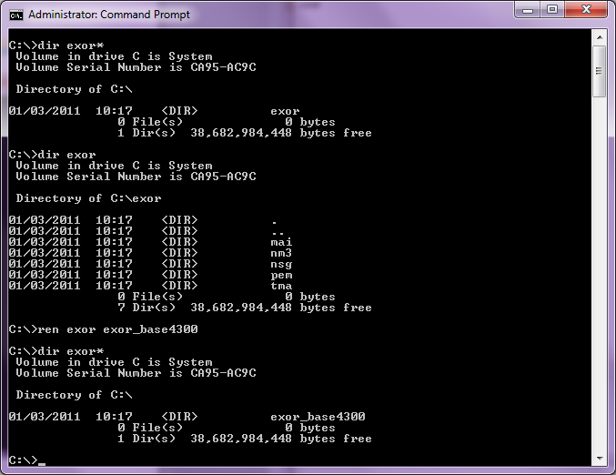

**… The installation can then continue into a clean area (e.g. c:\exor) by unzipping the release zip file. This will create a folder/directory structure with the release files which will be used to install or upgrade your system.**

* + 1. Release Software Component 4.6.0.0 Versions

|  |  |  |
| --- | --- | --- |
| **Component** | **Version** | **Patch Level** |
| Oracle Database Enterprise Edition | 11.2.0.2 | July 2011 CPU |
| WebLogic Sever 11g (10.3.5 R3) |  | Sept 2011 CPU |
| Oracle Fusion Middleware 11g |  | Sept 2011 CPU |
| Forms 11g |  | Sept 2011 CPU |
| Reports 11g |  | Sept 2011 CPU |
| ArcSde Server | 9.3.1 | sp1,sp2 & gpu 1 |

Further details about the components and their versions and patches please refer the exor certification matrix.

* + 1. Oracle Weblogic Server Configuration (Install and Upgrade)

**Please note that this section is applicable when performing an install or upgrade for 4.6.0.0 (as opposed to previous releases).**

**Please ensure that the Weblogic Application Server is installed and Fusion Middleware Forms and Reports are installed and configured before proceeding.**

Bentley-exor release 4.6.0.0 makes use of WebUtil functionality within the Oracle Weblogic Server Technology stack for Maintenance Manager (Inspection Loader), Document Manager (uploading documents and Document Bundle Loader) and the Process Framework. This requires additional configuration within the Weblogic Server Fusion Middleware Forms deployment.

Deploy Jacob files

Locate the files **jacob.dll** and **Jacob.jar** (version 1.10.1); these may be found in the **<*exor_base*>**\weblogic\ directory:-

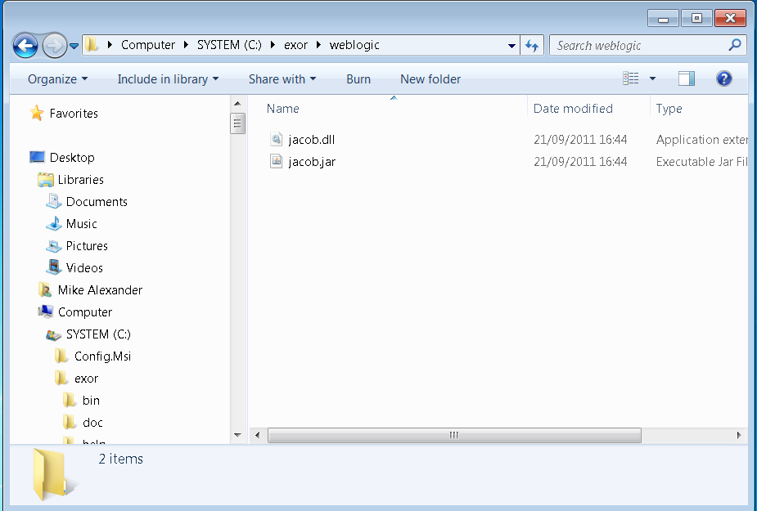

The **jacob.dll** file can then be copied into the ORACLE_HOME/forms/webutil/ directory of the weblogic server:-

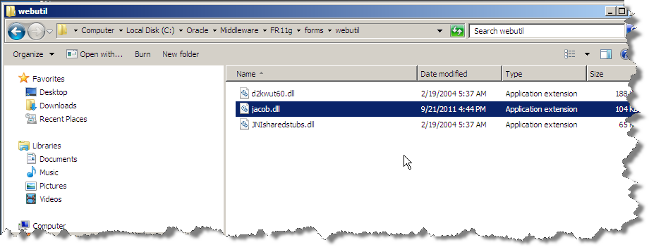

The **jacob.jar** file can then be copied into the ORACLE_HOME/forms/java/ directory of the weblogic server:-

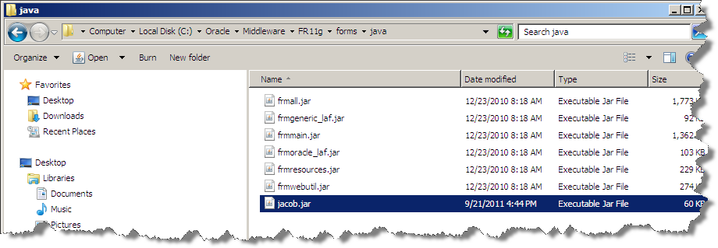

Signing Webutil

Ensure that the JAVA_HOME environment variable is set:

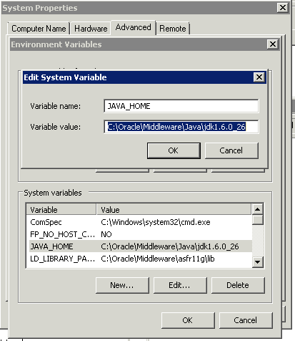

Check that the JAVA_HOME is set by issuing the command ‘echo %JAVA_HOME%

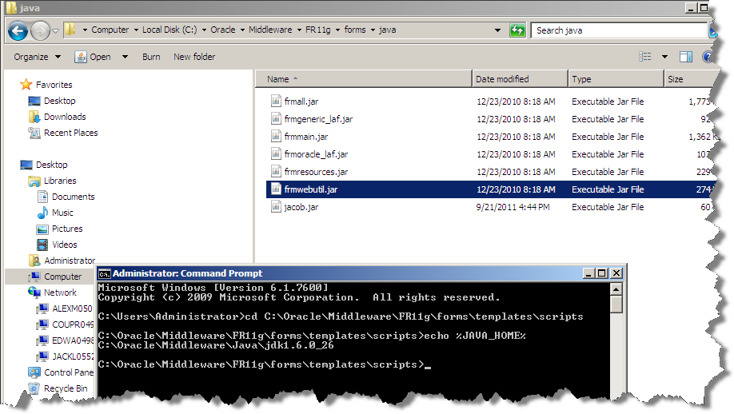

Locate the batch file to sign_webutil.bat under **ORACLE_HOME\forms\template\scripts\** and edit the file:

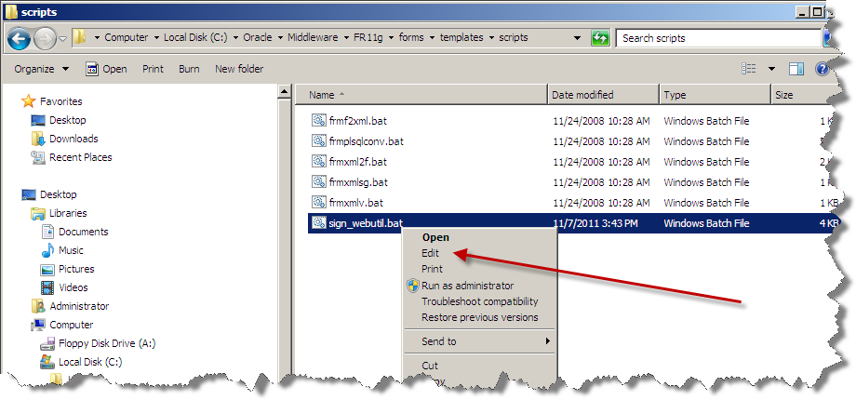

Ensure that the KEYSTORE_PASSWORD, JAR_KEY and JAR_KEY_PASSWORD variables are set correctly:

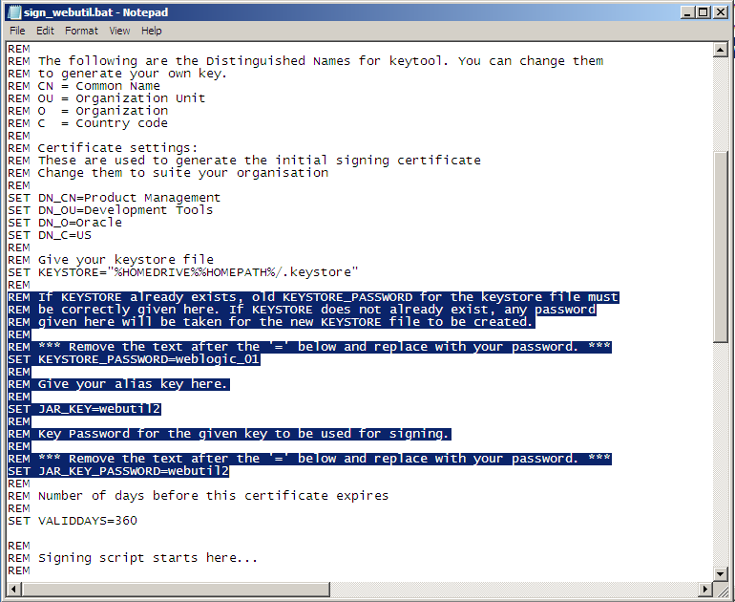

To generate the certificate ensure that the %JAVA_HOME% is set to the correct location. Replace %ORACLE_HOME% with the %JAVA_HOME% in the sign_webutil.bat file.

Original:

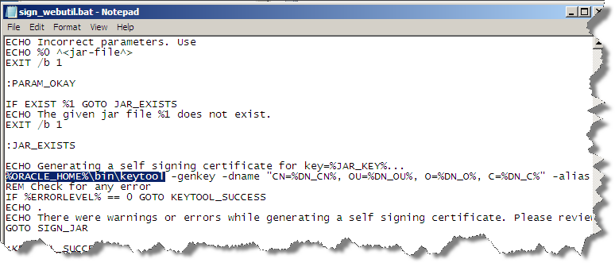

Changed to %JAVA_HOME%:

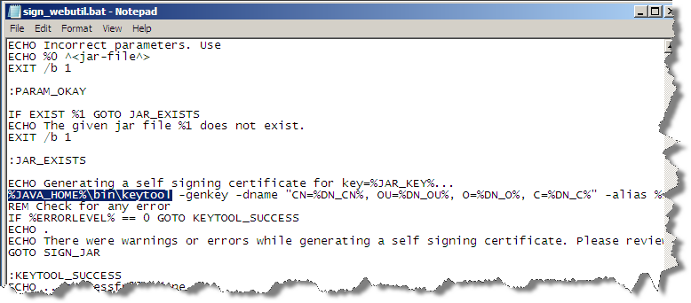

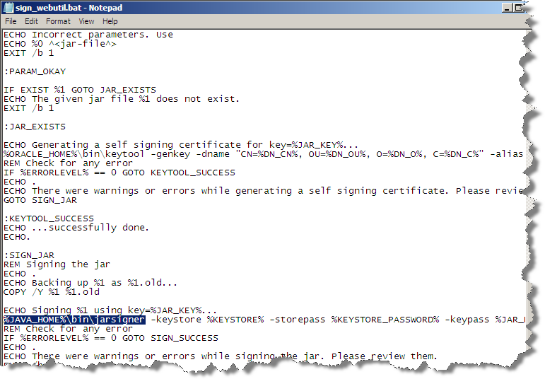

Open a DOS Command prompt and change directory to ORACLE_HOME/forms/templates/scripts/

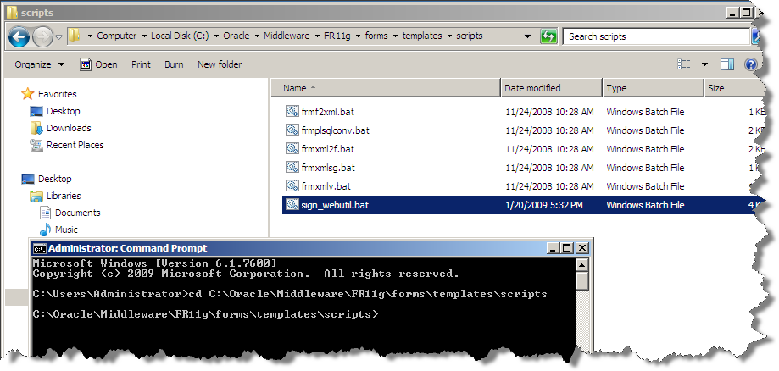

This is the location of the batch file ‘**sign_webutil.bat**’ that can be used to sign the webutil jar files.

Execute the batch file **sign_webutil.bat** to sign the jar files using the command ‘**sign_webutil.bat <ORACLE_HOME>\ forms\java\frmwebutil.jar**’:

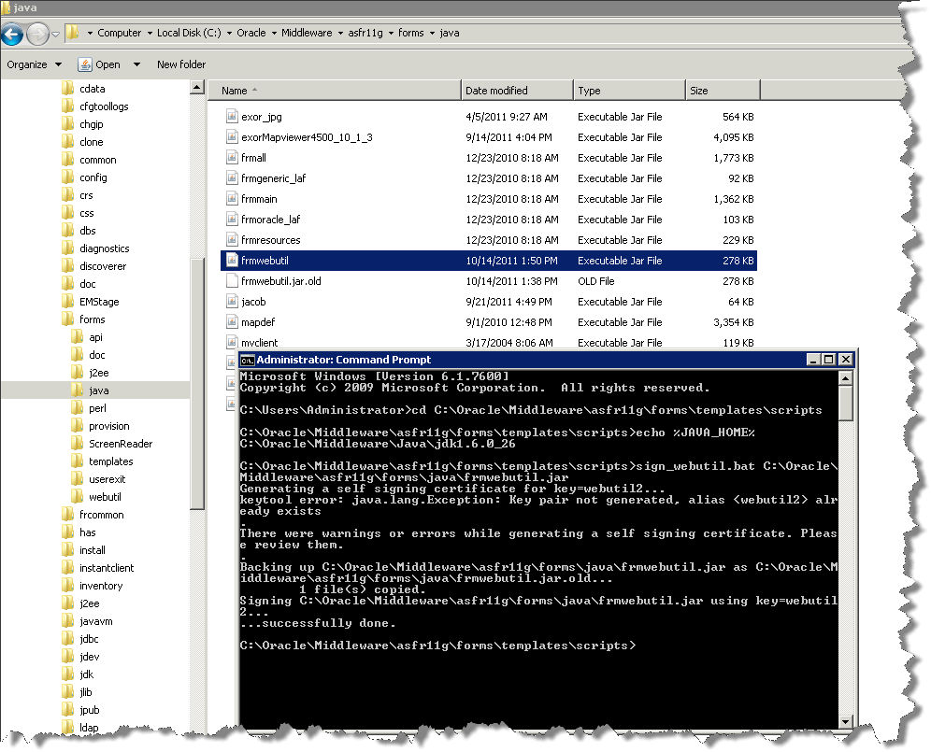

When successfully signed the old jar file will be renamed to frmwebutil.jar.old and replaced with the new signed version:

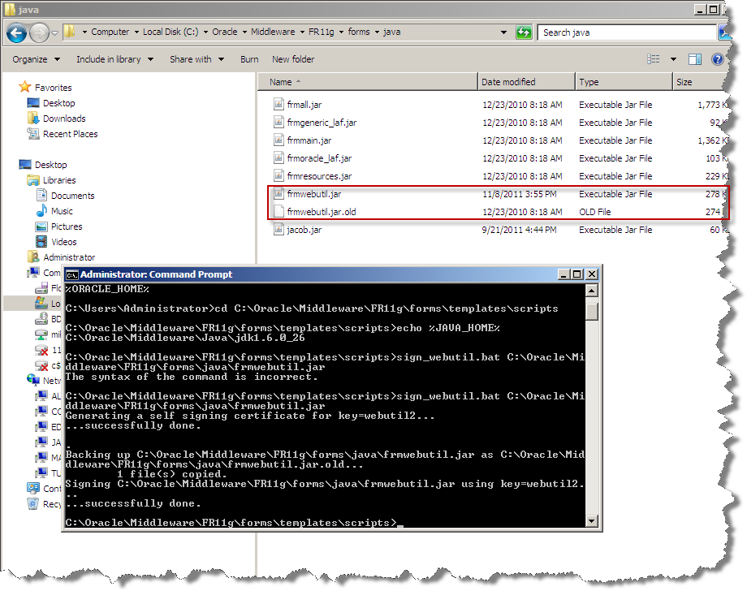

Using the same method, sign the Jacob.jar file also:

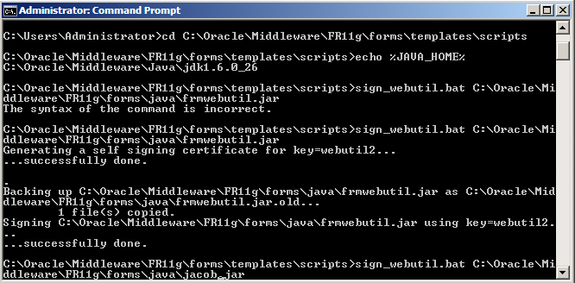

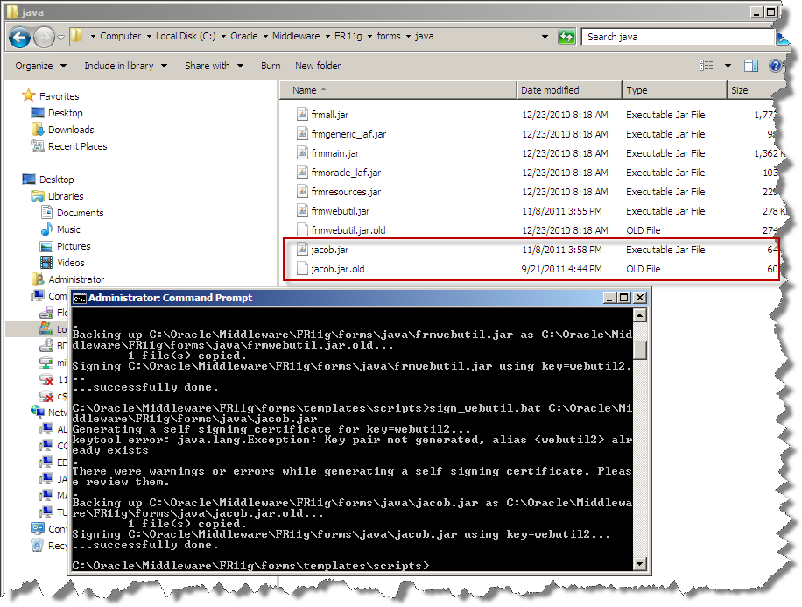

Edit webutiljpi.htm

It is not possible to edit the webutiljpi.htm file via enterprise manager; navigate to <ORACLE_INSTANCE>\config\FormsComponent\forms\server and open the webutiljpi.htm file using a suitable text editor.

The new PARAMETER_NAME and EMBEDDED SRC to allow a specific java version to be used should be added to the file in two sections, first the ‘Registration applet definition (start)’ section, then the ‘Forms applet definition (start)’ section – NOTE: in this section you will have to scroll down to the EMBED SRC section to add java_version. The screen shots below indicate this.

**NOTE in order to edit this file the Forms Service must be down, stop the Form Service using Fusion Middleware control.**

Add the new PARAMETER_NAME and EMBEDDED SRC as per below and save the file.

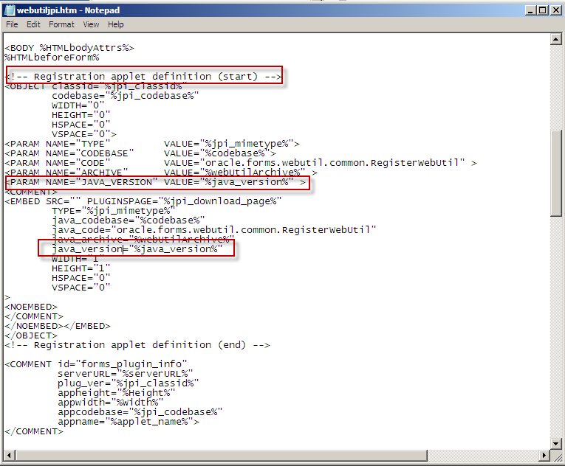

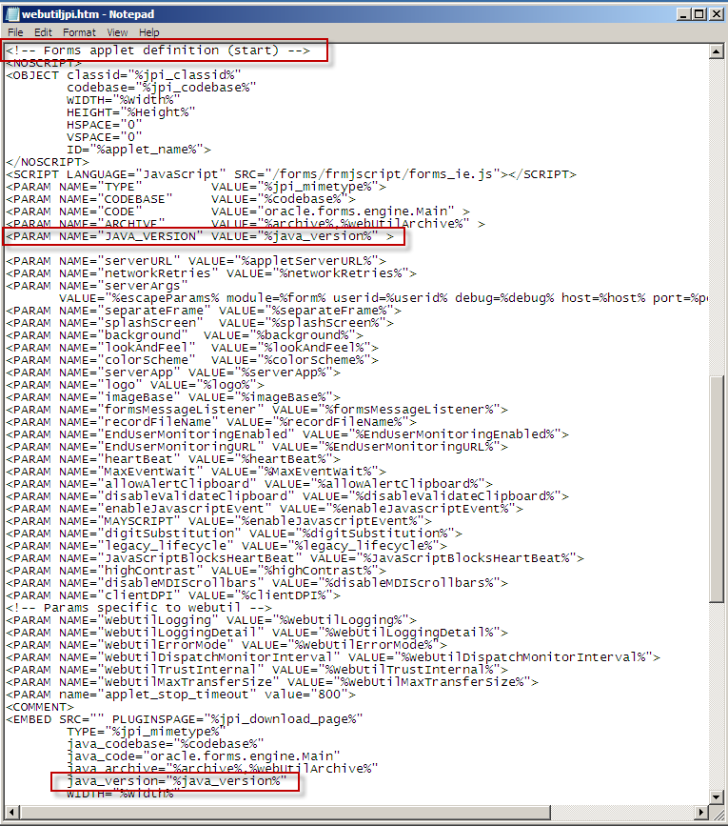

This additional new parameter allows the Application to force the use of a specific version of JRE specified in the formsweb.cfg file. Once the changes are completed the Forms services may be started.

Configure the Forms Service to use WebUtil

**Oracle Weblogic Server 10.3.5 - it is advisable to edit the configuration files using Fusion Middleware Control.**

Add the additional parameters to the default section of formsweb.cfg using Fusion Middleware control:

|  |  |
| --- | --- |
| **Parameter** | **Value** |
| term | **<Oracle_home>**\config\FormsComponent\forms\fmrpcweb.res |
| baseHTML | **<Oracle_home>**\config\FormsComponent\forms\server\webutilbase.htm |
| baseHTMLjpi | **<Oracle_home>**\config\FormsComponent\forms\server\webutiljpi.htm |
| highContrast | TRUE |
| height | 100% |
| form | hig1807.fmx |
| width | 100% |
| archive | frmall.jar,exor_jpg.jar,exorMapviewer4500_10_3_5.jar,mvclient_10_3_5.jar,uploadclient.jar,UploadServer.jar |
| separateFrame | TRUE |
| lookandfeel | oracle |
| WorkingDirectory | **<exor_base>**\bin |
| WebUtilArchive | frmwebutil.jar,jacob.jar |
| WebUtilLogging | on |
| WebutilLoggingDetails | normal |
| WebUtilErrorMode | Console |
| WebUtilDispatchMonitorInterval | 5 |
| WebUtilTrustInternal | TRUE |
| WebUtilMaxTransferSize | 16384 |

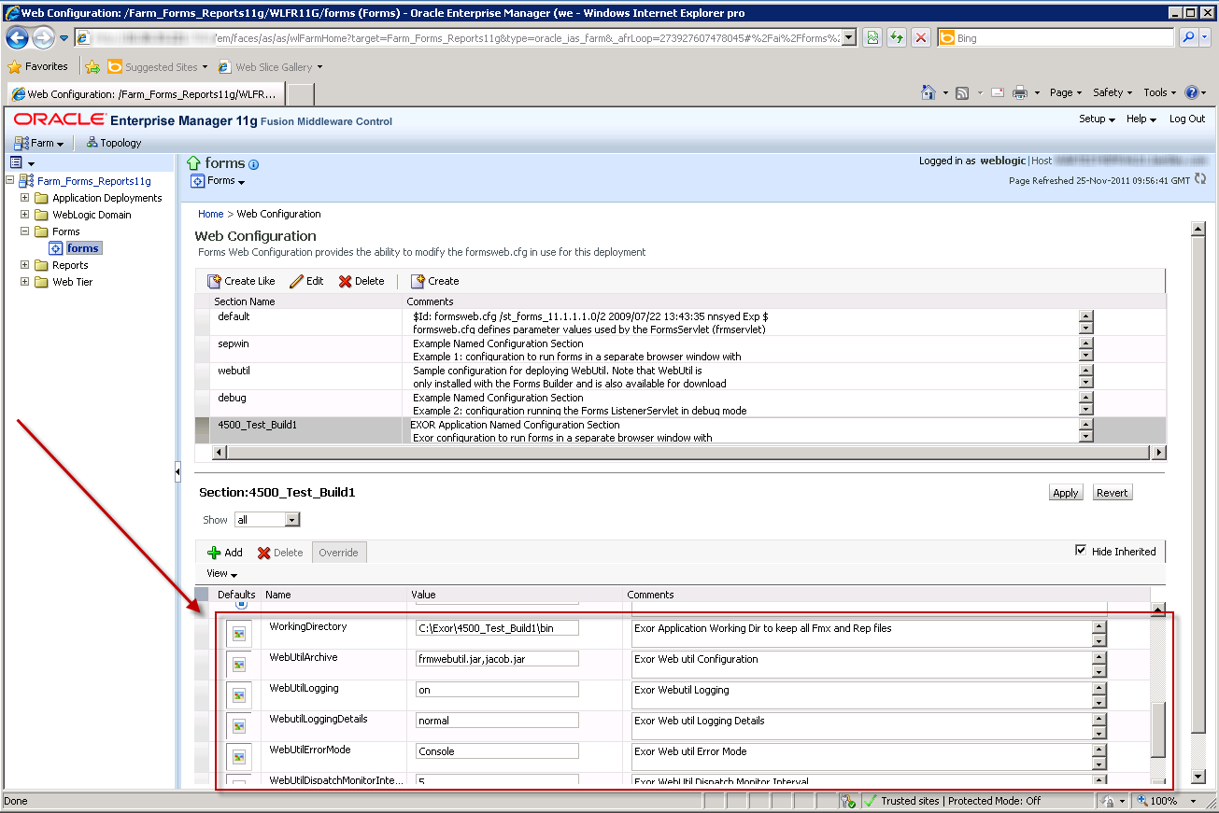

Ensure that frmwebutil.jar exists in the CLASSPATH variable and if it does not, add it now.

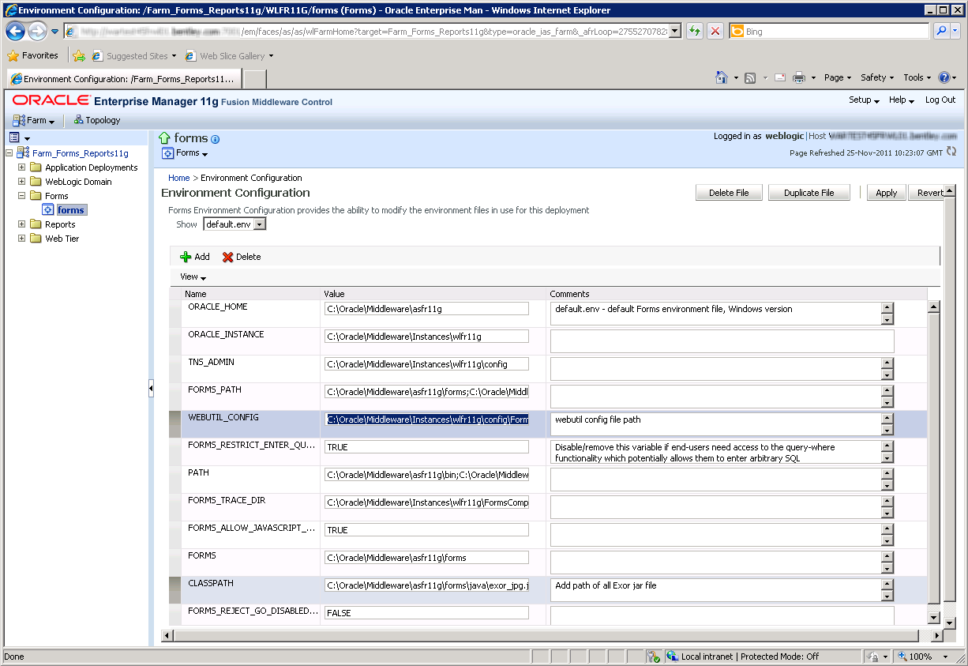

Configure the WebUtil

Edit the file, using a suitable text editor, located in the folder **<ORACLE_INSTANCE>**\config\FormsComponent\forms\server called **webutil.cfg**. There are numerous options that can be configured in webutil.cfg relating to Logging, OS specifics, Upload/Download, and work areas. Initially we only configure the File Transfer which requires the following change to webutil.cfg

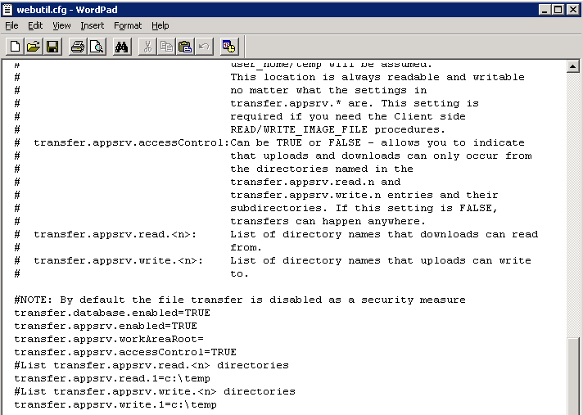

In the example above we have set the database and appsrv to be ‘TRUE’ with the default settings for transfer.appsrv.read and transfer.appsrv.write being at the default of c:\temp. We may need to add additional folders here to allow the upload on Maintenance Manager files etc to the specific Exor Directories.

1. Network Manager
   1. Installation of the Network Manager Software files

To install the software components for Network Manager first check that the NM3 folder is present and correctly unzipped from the release zip file.

**Important:**

All exor applications that you install must go into the same destination – what is often referred to as <***exor_base***>.

* 1. Highways Owner Account (Install Only)

This section provides details of steps involved in creating as owner for all exor database objects.

**Important:**

Only perform the steps outlined in this section if you do not already have a ‘Highways Owner’ account. If you are upgrading Network Manager then please skip to section 3.3.5.

* + 1. Before you start:

Before proceeding please ensure that the pre-requisites mentioned in **Section 2.4** of this document are met.

Also, please be aware of the following;

Where instructed to change to a directory before running a script, it is assumed that you are running SQL*PLUS from a DOS Command prompt.

If you are running SQL*PLUS in windows you should set the 'start in' directory of the SQL*PLUS shortcut to simulate the change of directory.

**If you do not run SQL*PLUS from the directory stated in each step of the guide, the installation will fail.**

Also, whilst following the instructions in this section you will be required to know the location of <***exor_base***>. You may recall that whilst undertaking the tasks in **Section 3.1** you will have implemented software into the location referred to as <***exor_base***>, for example, C:\EXOR.

* + 1. Creation of a Highways Owner

The following paragraphs should be used to create a new schema for the implementation of Network Manager and any other subsequent exor application.

**Tablespace Requirements**

The following tablespaces (or equivalents) should be made available on your server:

**HIGHWAYS** Default Table Space. Can be a different name if required.

**TEMP** Default temporary Tablespace for users. Can be a different name.

**Data Dictionary Privileges**

Change directory to **<*exor_base*>\nm3\install**

Login to SQL*PLUS as the **SYS** user on the client PC and run the following command :

start hig_sys_grants.sql

**The higowner script**

Change directory to **<*exor_base*>\nm3\install**

Login to SQL*PLUS as the **SYSTEM** user on the client PC and run the following command:

start higowner.sql

This script will prompt you for the following information:

|  |  |
| --- | --- |
| **Prompt** | **Meaning** |
| Highways Owner Name | This should be the name to be given to your highways owner |
| Owner’s Password | Password for highways owner |
| Default Tablespace | Default Tablespace for highways owner |
| Temporary Tablespace | Temporary Tablespace for highways owner |
| System Start Date | This is the earliest date at which data is valid in your database |
| Admin Type Code | Code for the default admin unit type |
| Admin Type Description | Description for the default admin unit type |
| Admin Unit Code | Code for the default Admin Unit |
| Admin Unit Description | Description for the default Admin Unit |

You will now have a new Oracle user set up with all relevant privileges to run the highways application. Also the system start date for your database will have been set and Top level Admin Unit created for your default Admin Unit Type.

* 1. Network Manager Server Install/Upgrade

This section provides details of steps involved in installing/upgrading the server components for Network Manager to 4.6.0.0.

**Important:**

This product will require upgrading ***before*** any other 4.6.0.0 product upgrades.

* + 1. Before you Start

Before proceeding please ensure that the pre-requisites mentioned in **Section 2.4** of this document are met.

Also, please be aware of the following;

Where instructed to change to a directory before running a script, it is assumed that you are running SQL*PLUS from a DOS Command prompt.

If you are running SQL*PLUS in windows you should set the 'start in' directory of the SQL*PLUS shortcut to simulate the change of directory.

**If you do not run SQL*PLUS from the directory stated in each step of the guide, the installation will fail.**

Also, whilst following the instructions in this section you will be required to know the location of <***exor_base***>. You may recall that whilst undertaking the tasks in **Section 3.1** you will have implemented software into the location referred to as <***exor_base***>, for example, C:\EXOR.

* + 1. Typical problems that you may encounter

It is possible that, when you are running some of the upgrade scripts, errors may be reported saying that objects already exist in the database or that columns already exist on tables. These errors can generally be ignored. If you are in any doubt, please contact the Exor support desk for guidance.

The upgrade procedures will also attempt to install database roles in the highways owner account that are necessary for the system to operate correctly. You may find that errors are produced when running the upgrade scripts to the effect that the role names being created are already used by existing roles or users. These errors can be ignored as they simply mean that the roles being created already exist.

Also during install/upgrade Warning messages may appear saying that compilation errors have occurred. These warnings can be ignored, since invalid objects will be recompiled later on in the install/upgrade. However it will be of concern if compilation errors still occur following the re-compilation.

* + 2. Install of Network manager

Core User and Objects

The following should be used to create a new schema for the implementation of Context Setting. This step is only required for a new install of Network Manager (i.e. not required if upgrading from a previous version of Network Manager).

Change directory to **<*exor_base*>\nm3\install**

Login to SQL*PLUS as the **SYSTEM** user on the client PC and

run the following command:

start exor_core_user_creation.sql

Login to SQL*PLUS as the **EXOR_CORE** user (Password EXOR_CORE) on the client PC and

run the following command:

start exor_core_objects.sql

Then continue with the Install of Network Manager.

Install of Network Manager

To create the base data and objects for Network Manager modules;

Change directory to **<*exor_base*>\nm3\install**

Login to SQL*PLUS as the highways owner on the client PC and run the following command:

  start nm_inst.sql

You will be prompted to enter the path of the location of your highways software. This should be name of the directory, including disk identifier and a trailing slash character, referred to as <***exor_base***>.

For example, if you installed your highways software in a directory called EXOR on your C drive, you would enter the following when prompted.

**C:\EXOR\**

When you have supplied this value, you will be prompted to confirm that it is correct and asked whether you wish to continue.

If the value specified is not correct or does not end with a slash character, you will be given an error message and the installation script will abort. You will then need to login to SQL*PLUS again and rerun the script.

When the script has completed, all the Network Manager objects and data will have been installed.

Checking Log File(s)

The following log files are produced in the working directory. At the end of the installation, the files can be viewed to check for any errors that could have occurred during installation.

nm3_install_1_<***date&time***>.LOG

nm3_install_2_<***date&time***>.LOG

**Note:**

it is perfectly normal for the NM3SDE package to not compile if an SDE schema does not exist or if the highways owner has no privilege to read SDE objects.

Please raise and attach the logs to a ticket with [**http://selectservices.bentley.com**](http://selectservices.bentley.com) to allow Bentley (formerly exor) support staff to verify the install has been successful.

* + 1. Post Install Tasks

Creation of Additional Database Objects

Once an **install** has been completed the following batch files must be run;

* import_nm_upload_files.bat
* ldjava_11g.bat (for customers with an Oracle 11gR2 RDBMS)

These may be found in the **<*exor_base*>**\nm3\install\ directory and should be run from the command prompt.

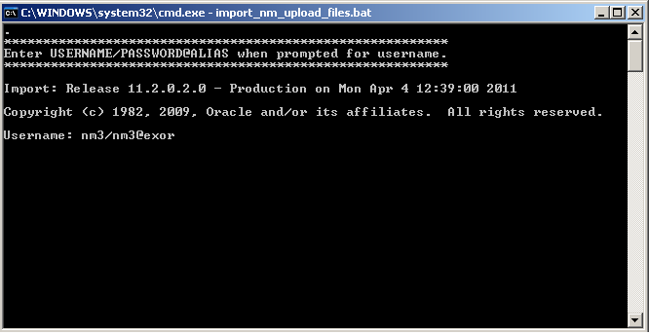

You will be prompted for the Username of the Highways Owner. Enter the Username/Password@alias then press Enter, e.g. nm3/nm3@exor

Synonyms

Highways product option HIGPUBSYN is used to dictate whether or not Public database synonyms are used.

On first time installation of Network Manager synonyms are NOT created. So to create synonyms following installation, use the Highways application to set product option HIGPUBSYN and then within SQL*Plus run the following command;

EXECUTE nm3ddl.refresh_all_synonyms;

Note:

if you opt to not use Public Synonyms, then Private synonyms are created for all subordinate users when the above command is executed.

Configuring NM3WEB

This section provides details of steps involved in configuring the Gateway Database Access Descriptor to allow access to the Web modules used within Highways by Exor.

These include modules such as the

CSV Loaders - HIGWEB2030

Engineering Dynamic Segmentation - NMWEB0020.

It refers to the base directory for files accessed through the OHS Weblogic server. By default this is **<ORACLE_INSTANCE>**\config\OHS\ohs1\mod_plsql\**dads.conf**.

A Database Access Descriptor (DAD) must be created to handle the connection to the database by the web server.

From the Oracle HTTP Server Advanced Server Configuration using Fusion Middleware control page

Select *dad.conf from files to be edited:*

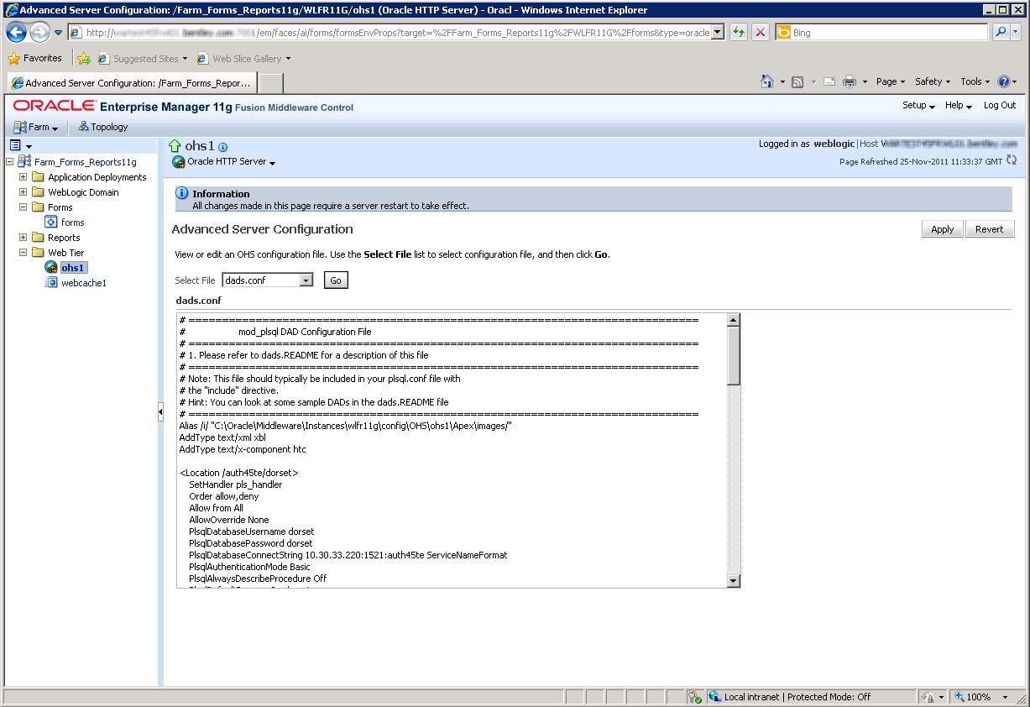

*Database Access Descriptor Name (****<Location /NM3WEB>***) should be NM3WEB

Fill in user, password and database as required.

You can leave the password and/or username blank to force the user to enter them (recommended).

***PlsqlDatabaseUsername*** should be blank.

***PlsqlDatabasePassword*** should be blank.

Authentication method ***(PlsqlAuthenticationMode)*** should be Basic.

Default Home page ***(PlsqlDefaultPage)*** should be nm3web.main_menu.

Document Table name (***PlsqlDocumentTablename)*** should be NM_UPLOAD_FILES.

Document Access Path (***PlsqlDocumentPath)*** should be the value set for Product Option WEBDOCPATH. The standard metadata value is DOCS

*Document Access Procedure (****PlsqlDocumentProcedure****)* should be nm3web.process_download

Click *OK* button at top of page.

Note:

In order to access the Web Modules the User must be granted the appropriate Roles for the Module. Refer to the General System Admin Guide for more information on User Roles

For example:

***<Location /NM3WEB>***

***SetHandler pls_handler***

***Order allow,deny***

***Allow from All***

***AllowOverride None***

***PlsqlDatabaseUsername <recommended to be blank>***

***PlsqlDatabasePassword < recommended to be blank >***

***PlsqlDatabaseConnectString <hostname>:<port>:<service_name> ServiceNameFormat***

***PlsqlAuthenticationMode Basic***

***PlsqlAlwaysDescribeProcedure Off***

***PlsqlDefaultPage nm3web.main_menu***

***PlsqlDocumentProcedure nm3web.process_download***

***PlsqlErrorStyle <as required>***

***PlsqlDocumentPath DOCS***

***PlsqlDocumentTablename NM_UPLOAD_FILES***

***</Location>***

Forms 11g Specific Configuration

There are certain product options which must be set according to the Oracle forms version that is being used to run the exor application.

REPURL

The value of this product option should be set to the URL that identifies the 11g Fusion Middleware Reports Server.

e.g.

http://<weblogic_server>:<port>/reports/rwservlet?server=<rep_server>

* + 2. Upgrade of Network Manager

Upgrade of Network Manager

This section describes the steps necessary to upgrade Network Manager to 4.6.0.0

To upgrade the base data and objects for the Network Manager modules;

* Change directory to **<*exor_base*>**\nm3\install
* Login to SQL*PLUS as the highways owner on the client PC
* Run the following command

start nm4500_nm4600.sql

* You will be prompted to enter the path of the location of your highways software. This should be name of the directory, including disk identifier and a trailing slash character, referred to as **<*exor_base*>.**

For example, if you installed your highways software in a directory called EXOR on your C drive, you would enter the following when prompted.

**C:\EXOR\**

* When you have supplied this value, you will be prompted to confirm that it is correct and asked whether you wish to continue.

* If the value specified is not correct or does not end with a slash character, you will be given an error message and the installation script will abort. You will then need to login to SQL*PLUS again and rerun the script.

* When the script has completed, all the Network Manager objects and data will have been upgraded.

Checking Log File(s)

The following log files are produced in the working directory. At the end of the upgrade, they can be viewed to check for any errors that could have occurred during the upgrade process.

nm4500_nm4600_1_<***date&time***>.LOG

nm4500_nm4600_2_<***date&time***>.LOG

Please raise and attach the logs to a ticket with [**http://selectservices.bentley.com**](http://selectservices.bentley.com) to allow Bentley (formerly exor) support staff to verify the upgrade has been successful.

Due to interdependencies between some Exor products, please ignore all compilation errors until all of your products have been upgraded.

* + 1. Mandatory Configuration (Post Install and Upgrade)

exor_version.txt

Before accessing Network Manager you must check the file exor_version.txt.

This file is referenced in Windows Registry setting ‘EXOR_VERSION’ and by default can be located in the <***exor_base***>\bin directory.

Ensure that the entry for Network Manager is set accordingly;

**NET=4.6.0.0**

**HIG=4.6.0.0**

**AST=4.6.0.0**

**DOC=4.6.0.0**

**WMP=4.6.0.0**

* + 1. EXOR_JPG.JAR (Post Install and Upgrade)

Copy the new EXOR_JPG.JAR from the <exor_base>/icons/java folder to the <forms_home>/java folder on the application server.

Users may need to clear their JRE caches to see the changes.

* + 1. Process Framework (Post Install and Upgrade)

The Process Framework can be started (or stopped) via the Process Framework Administration form (hig2550). After successfully completing installs or upgrades to 4.5.0.0 for all products required navigate to this form and use the Start Up button to start up the Process Framework.

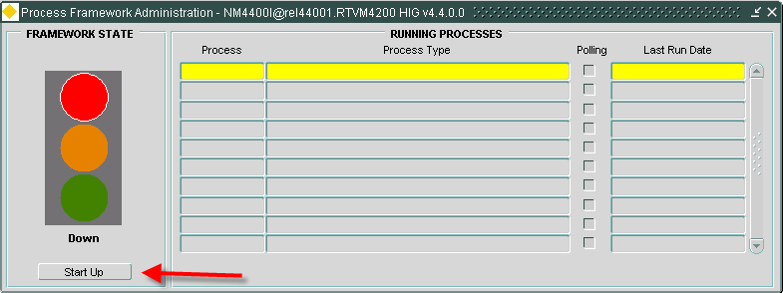

* + 1. Jobs (Post Install and Upgrade)

After completing a successful install/upgrade of all products required to 4.6.0.0 please execute the following script to start/restart Core jobs:

* Change directory to **<*exor_base*>**\nm3\install
* Login to SQL*PLUS as the highways owner on the client PC
* Run the following command

start nm3jobs.sql

* + 1. Spatial Configuration (Post Install and Upgrade)

Specific information regarding the registration of spatial layers can be found in the ***“Locator and Web Mapping”*** document.

* + 1. Doc Bundle Loader (Post Install and Upgrade)

Oracle External Scheduler Jobs

* For databases that exist on a Windows Operating System – The OracleJobScheduler<instance> service MUST be running on the database server.
* For databases that exist on a Solaris/Linux Operating System – Relevant permissions to execute <db_home>/bin/extjob must be set in accordance with Oracle Documentation.
* External Jobs are not supported on any other platform.
  + 1. Additional Configuration (Post Install and Upgrade)

Consult the documentation that accompanies this release for details of any additional configuration that may be required following an install/upgrade.

For example, to obtain details of product options, and for details of new product features/amendments.

**Important:**

It is highly recommended that you do this before attempting to use the application.

* + 1. Mapserver Component Install (Post Install and Upgrade)

At version 4.6.0.0 of the Exor Application set, locator mapping software using Oracle Weblogic Application Server Mapviewer version 11.1.1.5 should be installed and configured.

Locate the <**exor_base**>\msv\exorMapviewer4500 where you will find exorMapviewer4500_10_3_5.jar and <**exor_base**>\msv\mvclient where you will find mvclient_10_3_5.jar. Copy these files to **<oracle_home>**\forms\java.

The formsweb.cfg archive parameter should be appended with the file name exorMapviewer4500_10_3_5.jar and mvclient_10_3_5.jar.

**For example (formsweb.conf):**

archive=frmall.jar,exor_jpg.jar,exorMapviewer4500_10_3_5.jar,mvclient_10_3_5.jar,uploadclient.jar,UploadServer.jar

On each client machine the Jar Cache will need to be cleared. This can be done by the following methods.

Sun JRE users

Start-> Settings-> Control Panel-> Java. Navigate to the "General" tab and click "Settings" button. In the Disk Space section click "Delete Files" button

You should now load the exor application in the usual way. On the first load, it will take longer than usual whilst the JAR files are cached again.

MV_SECURITY Option

Please ensure that the MV_SECURITY option in the Mapviewer config file is set to FALSE. This has to be set to FALSE so that the Java code can create a data source on the fly when the preferred data source is not set.

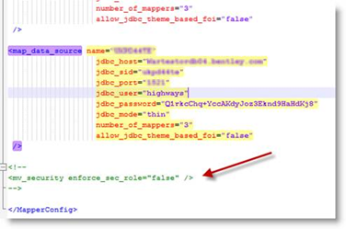

1. MapCapture Interface
   1. Implementation of the MapCapture Interface Software files

To install the software components for MapCapture Interface check that the MCP folder has been correctly unzipped from the release zip file.

* 1. MapCapture Interface Server Install/Upgrade

This chapter provides details of steps involved in installing/upgrading the server components for MapCapture Interface.

**Important:**

This product will require installing/upgrading ***after*** Network Manager and Maintenance Manager.

* + 1. Before you Start

Before proceeding please ensure that the pre-requisites mentioned in **Section 2.4** of this document are met.

Also, please be aware of the following;

Where instructed to change to a directory before running a script, it is assumed that you are running SQL*PLUS from a DOS Command prompt.

If you are running SQL*PLUS in windows you should set the 'start in' directory of the SQL*PLUS shortcut to simulate the change of directory.

**If you do not run SQL*PLUS from the directory stated in each step of the guide, the installation will fail.**

Also, whilst following the instructions in this section you will be required to know the location of <***exor_base***>.

* + 1. Typical problems that you may encounter

It is possible that, when you are running some of the upgrade scripts, errors may be reported saying that objects already exist in the database or that columns already exist on tables. These errors can generally be ignored. If you are in any doubt, please contact the Exor support desk for guidance.

The upgrade procedures will also attempt to install database roles in the highways owner account that are necessary for the system to operate correctly. You may find that errors are produced when running the upgrade scripts to the effect that the role names being created are already used by existing roles or users. These errors can be ignored as they simply mean that the roles being created already exist.

Also during install/upgrade Warning messages may appear saying that compilation errors have occurred. These warnings can be ignored, since invalid objects will be recompiled prompt later on in the install/upgrade. However it will be of concern if compilation errors still occur following the re-compilation and completion of post installation tasks.

* + 1. Install of MapCapture Interface

To create the base data and objects for the MapCapture Interface modules;

* Change directory to **<*exor_base*>**\mcp\install

Login to SQL*PLUS as the highways owner on the client PC and run the following command

start mcp_inst.sql

* You will be prompted to enter the path of the location of your highways software. This should be name of the directory, including disk identifier and a trailing slash character, referred to as **<*exor_base*>.**

For example, if you installed your highways software in a directory called EXOR on your C drive, you would enter the following when prompted.

**C:\EXOR\**

* When you have supplied this value, you will be prompted to confirm that it is correct and asked whether you wish to continue.

* If the value specified is not correct or does not end with a slash character, you will be given an error message and the installation script will abort. You will then need to login to SQL*PLUS again and rerun the script.
* When the script has completed, all the MapCapture Interface objects and data will have been installed.

Checking Log File(s)

The following log files are produced in the working directory. At the end of the install, they can be viewed to check for any errors that could have occurred during the install process.

mcp_install_1_<***date&time***>.LOG

mcp_install_2_<***date&time***>.LOG

Please raise and attach the logs to a ticket with [**http://selectservices.bentley.com**](http://selectservices.bentley.com) to allow Bentley (formerly exor) support staff to verify the install has been successful.

Due to interdependencies between some Exor products, please ignore all compilation errors until all of your products have been installed.

* + 1. Upgrade of MapCapture Interface

This section describes the steps necessary to upgrade MapCapture Interface to 4.6.0.0

To upgrade the base data and objects for the MapCapture Interface modules;

* Change directory to **<*exor_base*>**\mcp\install
* Login to SQL*PLUS as the highways owner on the client PC
* Run the following command

start mcp4500_mcp4600.sql

* You will be prompted to enter the path of the location of your highways software. This should be name of the directory, including disk identifier and a trailing slash character, referred to as **<*exor_base*>.**

For example, if you installed your highways software in a directory called EXOR on your C drive, you would enter the following when prompted.

**C:\EXOR\**

* When you have supplied this value, you will be prompted to confirm that it is correct and asked whether you wish to continue.

* If the value specified is not correct or does not end with a slash character, you will be given an error message and the installation script will abort. You will then need to login to SQL*PLUS again and rerun the script.
* When the script has completed, all the MapCapture Interface objects and data will have been upgraded.

Checking Log File(s)

The following log files are produced in the working directory. At the end of the upgrade, they can be viewed to check for any errors that could have occurred during the upgrade process.

mcp4500_mcp4600_1_<***date&time***>.LOG

mcp4500_mcp4600_2_<***date&time***>.LOG

Please raise and attach the logs to a ticket with [**http://selectservices.bentley.com**](http://selectservices.bentley.com) to allow Bentley (formerly exor) support staff to verify the upgrade has been successful.

Due to interdependencies between some Exor products, please ignore all compilation errors until all of your products have been installed. Also, objects may be invalid for certain products due to post configuration tasks not being completed. In this case reassess invalid objects when post installation task have been completed.

* + 1. Post Upgrade Tasks

After the upgrade of MapCapture Interface has completed it is necessary to create the metadata for the loader.

* Change directory to **<*exor_base*>**\mcp\install
* Login to SQL*PLUS as the highways owner on the client PC
* Run the following command

start mcp_nlf_data.sql

* + 1. Mandatory Configuration

exor_version.txt

Before accessing MapCapture Interface you must check the file exor_version.txt.

This file is referenced in Windows Registry setting ‘EXOR_VERSION’ and by default can be located in the <***exor_base***>\bin directory.

Ensure that the entry for MapCapture Interface is set accordingly;

**MCP=4.6.0.0**

1. UKPMS
   1. Implementation of the UKPMS Software files

To install the software components for UKPMS check that the UKP folder has been correctly unzipped from the release zip file.

* 1. UKPMS Server Install/Upgrade

This chapter provides details of steps involved in installing/upgrading the server components for UKPMS.

**Important:** This product will require installing/upgrading ***after*** Network Manager.

* + 1. Before you Start

Before proceeding please ensure that the pre-requisites mentioned in **Section 2.4** of this document are met.

Also, please be aware of the following;

Where instructed to change to a directory before running a script, it is assumed that you are running SQL*PLUS from a DOS Command prompt.

If you are running SQL*PLUS in windows you should set the 'start in' directory of the SQL*PLUS shortcut to simulate the change of directory.

**If you do not run SQL*PLUS from the directory stated in each step of the guide, the installation will fail.**

Also, whilst following the instructions in this section you will be required to know the location of <***exor_base***>. You may recall that whilst undertaking the tasks in **Section 19.1** you will have implemented software into the location referred to as <***exor_base***>, for example, C:\EXOR.

* + 1. Typical problems that you may encounter

It is possible that, when you are running some of the upgrade scripts, errors may be reported saying that objects already exist in the database or that columns already exist on tables. These errors can generally be ignored. If you are in any doubt, please contact the Exor support desk for guidance.

The upgrade procedures will also attempt to install database roles in the highways owner account that are necessary for the system to operate correctly. You may find that errors are produced when running the upgrade scripts to the effect that the role names being created are already used by existing roles or users. These errors can be ignored as they simply mean that the roles being created already exist.

Also during install/upgrade Warning messages may appear saying that compilation errors have occurred. These warnings can be ignored, since invalid objects will be recompiled prompt later on in the install/upgrade. However it will be of concern if compilation errors still occur following the re-compilation and completion of post installation tasks.

* + 1. Install of UKPMS

To create the base data and objects for UKPMS modules;

Change directory to **<*exor_base*>\ukp\install**

Login to SQL*PLUS as the highways owner on the client PC and run the following command:

  start ukp_inst.sql

You will be prompted to enter the path of the location of your highways software. This should be name of the directory, including disk identifier and a trailing slash character, referred to as <***exor_base***>.

For example, if you installed your highways software in a directory called EXOR on your C drive, you would enter the following when prompted.

**C:\EXOR\**

When you have supplied this value, you will be prompted to confirm that it is correct and asked whether you wish to continue.

If the value specified is not correct or does not end with a slash character, you will be given an error message and the installation script will abort. You will then need to login to SQL*PLUS again and rerun the script.

When the script has completed, all the UKPMS objects and data will have been installed.

Checking Log File(s)

The following log files are produced in the working directory. At the end of the installation, the files can be viewed to check for any errors that could have occurred during installation.

ukp_install_1_<***date&time***>.LOG

ukp_install_2_<***date&time***>.LOG

**Note:** following the install it is usual for packages NET1119 and/or UKPMS_ROAD_CONDITION to be invalid. Once the **UR Asset Type** has been assigned and **UKPMS inventory views** are regenerated (as part of the post install tasks), the packages should be valid. The post install tasks are detailed in the accompanying Release Notes for UKP 4500.

Please raise and attach the logs to a ticket with [**http://selectservices.bentley.com**](http://selectservices.bentley.com) to allow Bentley (formerly exor) support staff to verify the install has been successful.

Also, objects may be invalid for certain products due to post configuration tasks not being completed. In this case reassess invalid objects when post installation task have been completed.

* + 1. Upgrade of UKPMS

This section describes the steps necessary to upgrade UKPMS to 4.6.0.0

To upgrade the base data and objects for the UKPMS modules;

* Change directory to **<*exor_base*>**\ukp\install
* Login to SQL*PLUS as the highways owner on the client PC
* Run the following command

start ukp4500_ukp4600.sql

* You will be prompted to enter the path of the location of your highways software. This should be name of the directory, including disk identifier and a trailing slash character, referred to as **<*exor_base*>.**

For example, if you installed your highways software in a directory called EXOR on your C drive, you would enter the following when prompted.

**C:\EXOR\**

* When you have supplied this value, you will be prompted to confirm that it is correct and asked whether you wish to continue.

* If the value specified is not correct or does not end with a slash character, you will be given an error message and the installation script will abort. You will then need to login to SQL*PLUS again and rerun the script.
* When the script has completed, all the UKPMS objects and data will have been upgraded.

Checking Log File(s)

The following log files are produced in the working directory. At the end of the upgrade, they can be viewed to check for any errors that could have occurred during the upgrade process.

ukp4500_ukp4600_1_<***date&time***>.LOG

ukp4500_ukp4600_2_<***date&time***>.LOG

**Note:** following the upgrade it is usual for packages NET1119 and/or UKPMS_ROAD_CONDITION to be invalid. Once the **UR Asset Type** has been assigned and **UKPMS inventory views** are regenerated (as part of the post upgrade tasks), the packages should be valid. The post upgrade tasks are detailed in the accompanying Release Notes for UKP 4600.

Please raise and attach the logs to a ticket with [**http://selectservices.bentley.com**](http://selectservices.bentley.com) to allow Bentley (formerly exor) support staff to verify the upgrade has been successful.

Due to interdependencies between some Exor products, please ignore all compilation errors until all of your products have been installed. Also, objects may be invalid for certain products due to post configuration tasks not being completed. In this case reassess invalid objects when post installation task have been completed.

* + 1. Mandatory Configuration

exor_version.txt

Before accessing UKPMS you must check the file exor_version.txt.

This file is referenced in Windows Registry setting ‘EXOR_VERSION’ and by default can be located in the <***exor_base***>\bin directory.

Ensure that the entry for UKPMS is set accordingly;

**UKP=4.6.0.0**

* + 1. Product Licencing

Following **first time installation** you must licence the product for use.

To do this start highways by exor and invoke module HIG1890 from the Fastpath menu.

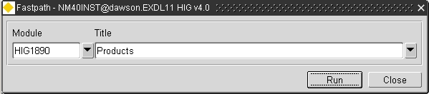

For further details please refer to the “**Network Manager General System Admin Guide**”

* + 1. Additional Configuration

Consult the documentation that accompanies this release for details of any additional configuration that may be required following an install/upgrade.

For example, to obtain details of product options, and for details of new product features/amendments.

**Important:**

It is highly recommended that you do this before attempting to use the application.